EC60007 Computational Neuroscience, Project I
Submission by: Siddharth Shankar Jha, 14EE30022

- The reduced state space form of the equation is as follows:
y₁=y
dy₁/dt=y₂
µ⁻¹dy₂/dt=(1-y₁²) – µ⁻¹y₁
- The code to solve and plot the differential equation
function[T,Y] = call_osc()
tspan =[0 300]; y1_0 = 1; y2_0 = 0;
[T,Y] = ode15s(@osci,[0 60],[y1_0 y2_0]);
[T1,Y1] = ode15s(@osci1,[0 100],[y1_0 y2_0]);
[T2,Y2] = ode15s(@osci2,[0 300],[y1_0 y2_0]);

figure
subplot(3,1,1); plot(T,Y(:,1)); title('u=0.1');
subplot(3,1,2); plot(T1,Y1(:,1)); title('u=1');
subplot(3,1,3); plot(T2,Y2(:,1)); title('u=100');

figure
subplot(3,1,1); plot(Y(:,1),Y(:,2)); title('u=0.1');
subplot(3,1,2); plot(Y1(:,1),Y1(:,2)); title('u=1');
subplot(3,1,3); plot(Y2(:,1),Y2(:,2)); title('u=100');
end

function dydt =osci(t,y)
dydt =[y(2) ; 0.1*(1-y(1)^2)*y(2) - y(1)];
end
function dydt =osci1(t,y)
dydt =[y(2) ; 1*(1-y(1)^2)*y(2) - y(1)];
end
function dydt =osci2(t,y)
dydt =[y(2) ; 100*(1-y(1)^2)*y(2) - y(1)];
end
- The ODE 15s format was found to be quite faster than ODE 45, especially when large time frames were involved. Noticeable slowdown was seen when time span of simulation was increased to 300 seconds from the starting. But ODE 45s generally has a higher accuracy, although no improvement was seen for this equation.
- The plots that were obtained were:
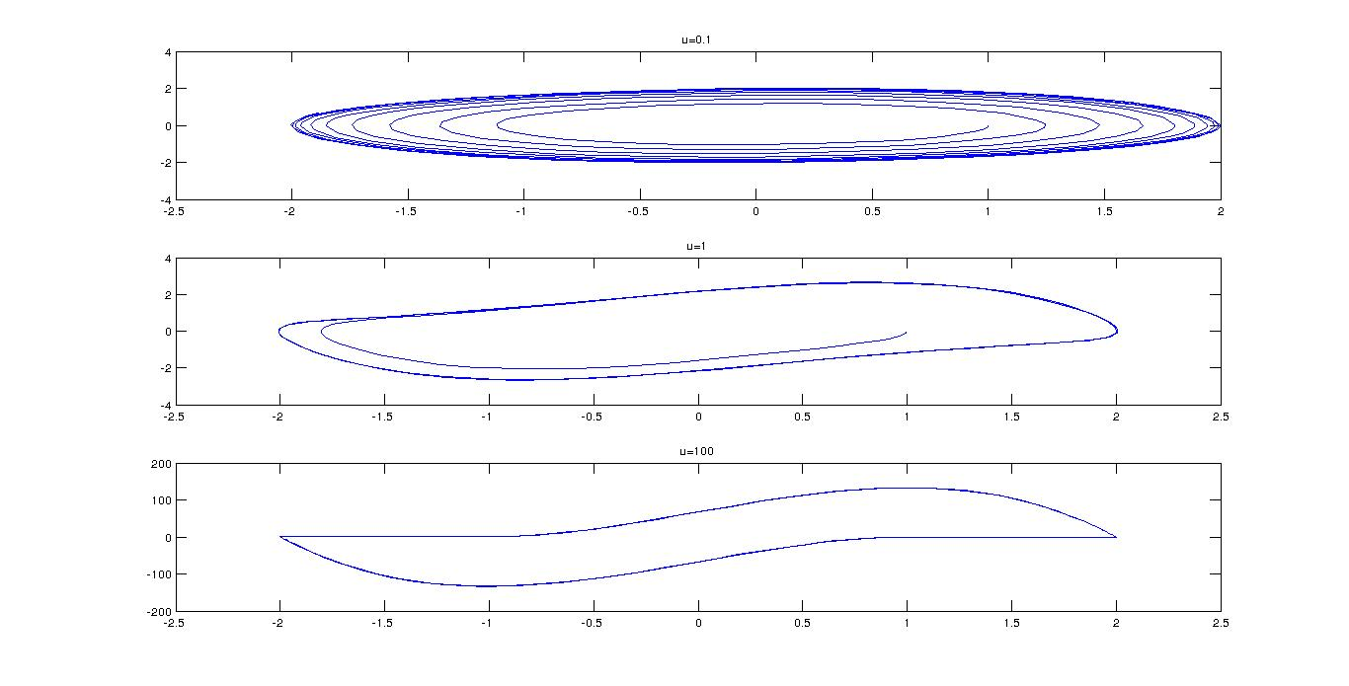

Phase Plane plots for different µ

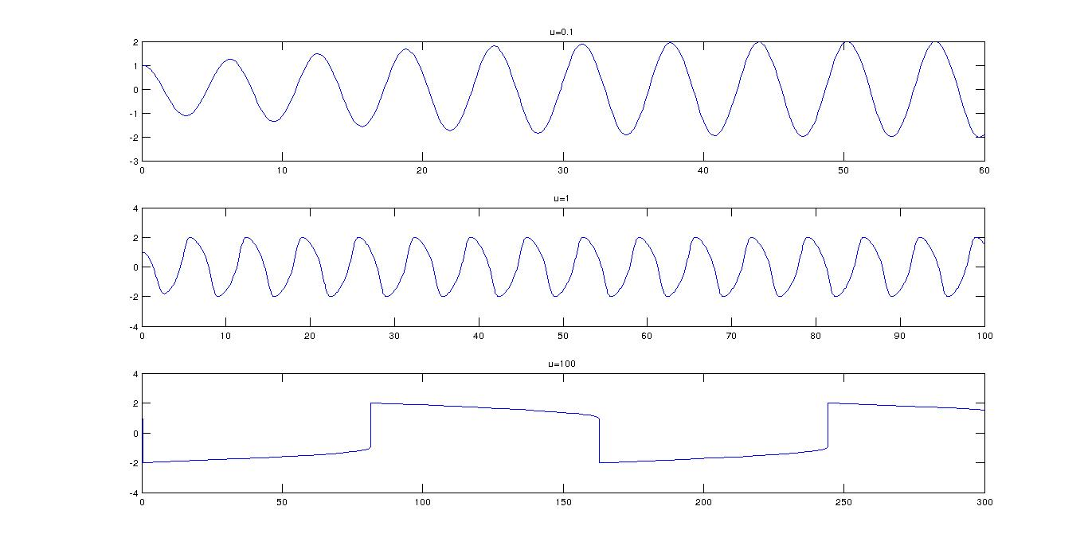

Time axis plots for different µ

- It is seen observing the phase plane plots that by increasing the value of µ, the curves start becoming less elliptical and more of a sinusoidal boundary-ish figures.

